Your submission for this activity should be a Word document that includes the following screenshots, each labeled for the step that the screenshot represents:

1. Provide a screenshot of your Docker desktop to show all of the Hadoop *containers* running.

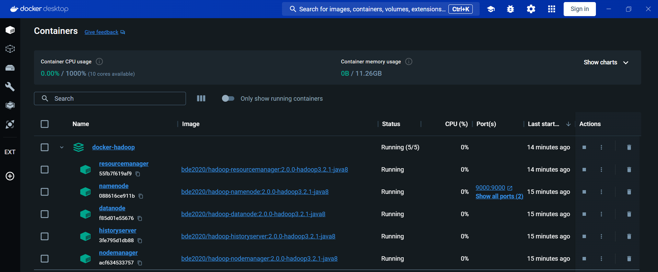

1. Provide a screenshot of your local machine to show that you successfully downloaded the Moby Dick .zip file and unzipped its contents to your local machine.

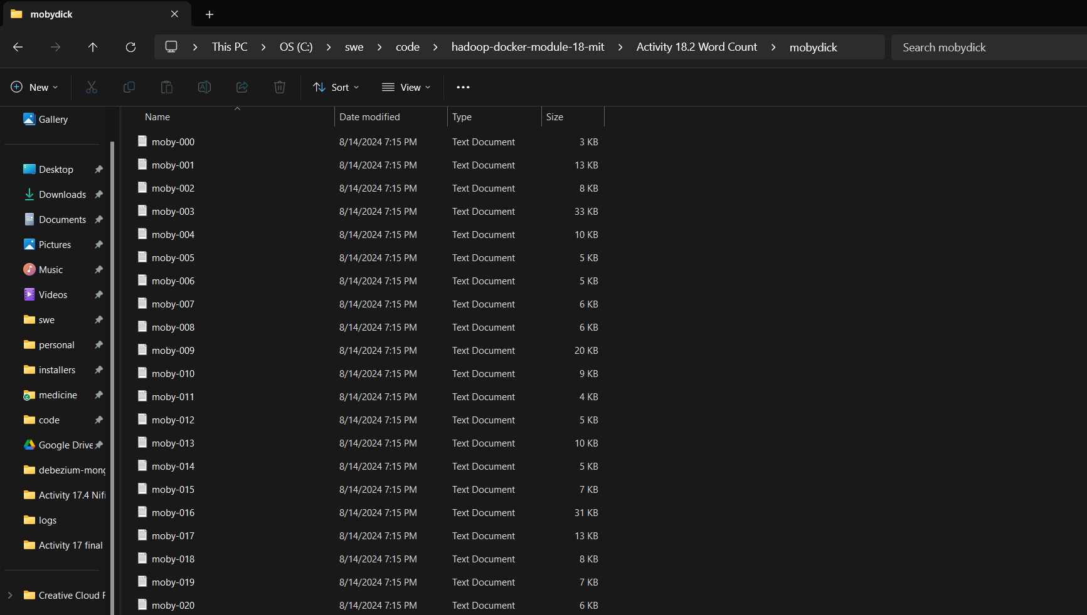

1. Provide a screenshot to show that you successfully created the input folder in the namenode *container*.

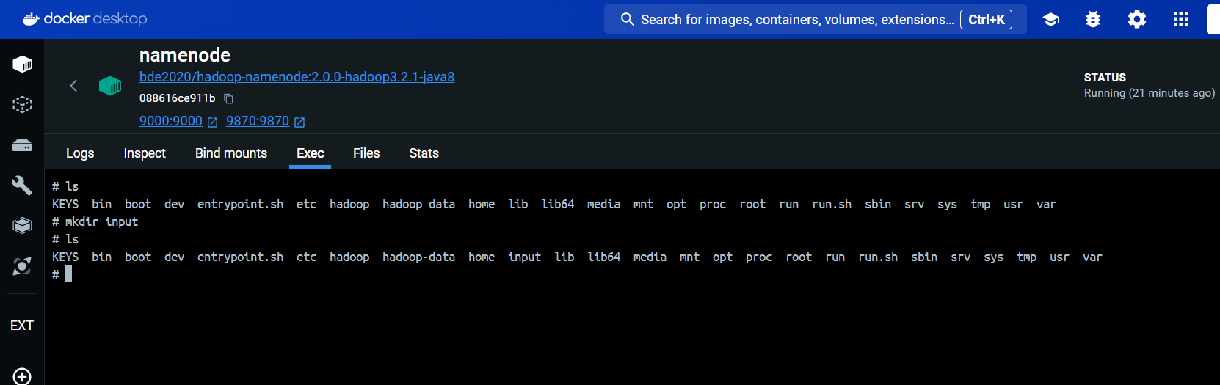

1. Provide a screenshot to show that you successfully copied the .txt file to the namenode *container*.

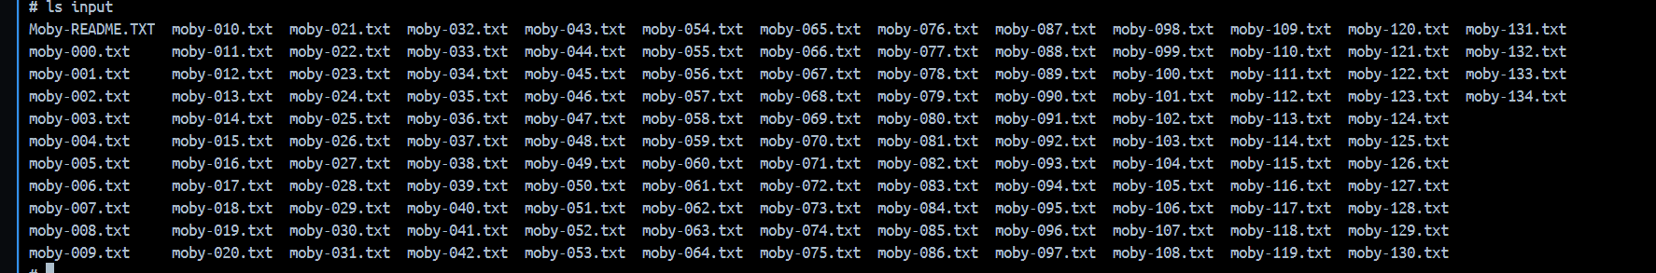

1. Provide a screenshot to show that you successfully created an input folder.



1. Provide a screenshot to show that you successfully ran the HDFS command to copy the contents of the local input folder to the HDFS input folder.

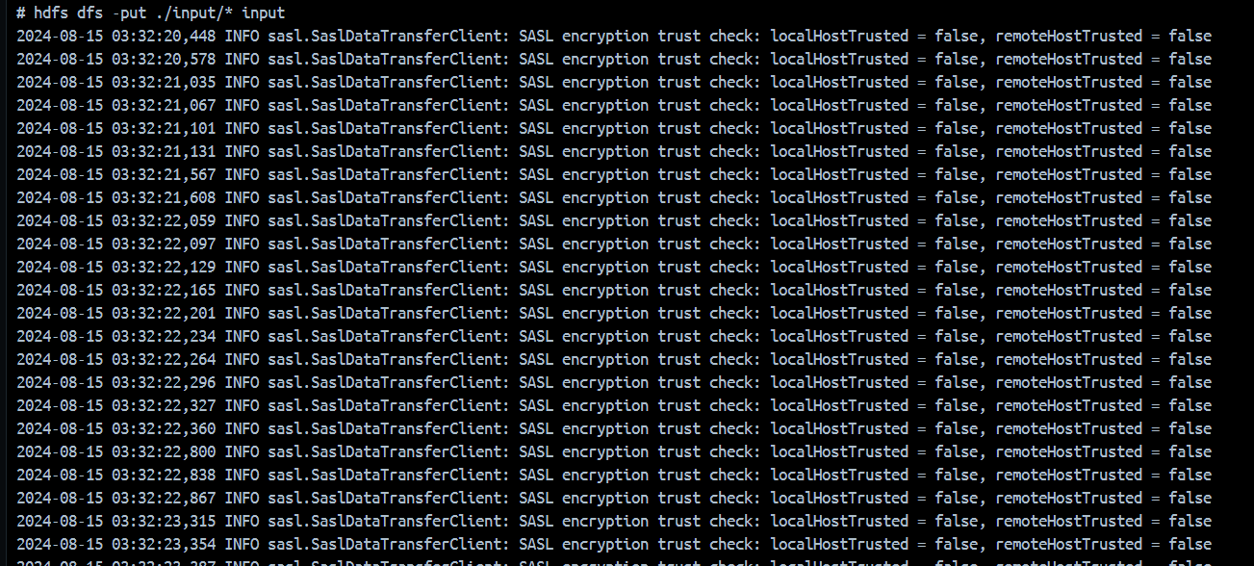

1. Provide a screenshot to show that you successfully ran the curl command to download the jar file.



1. Provide a screenshot to show that you successfully ran the word count program.

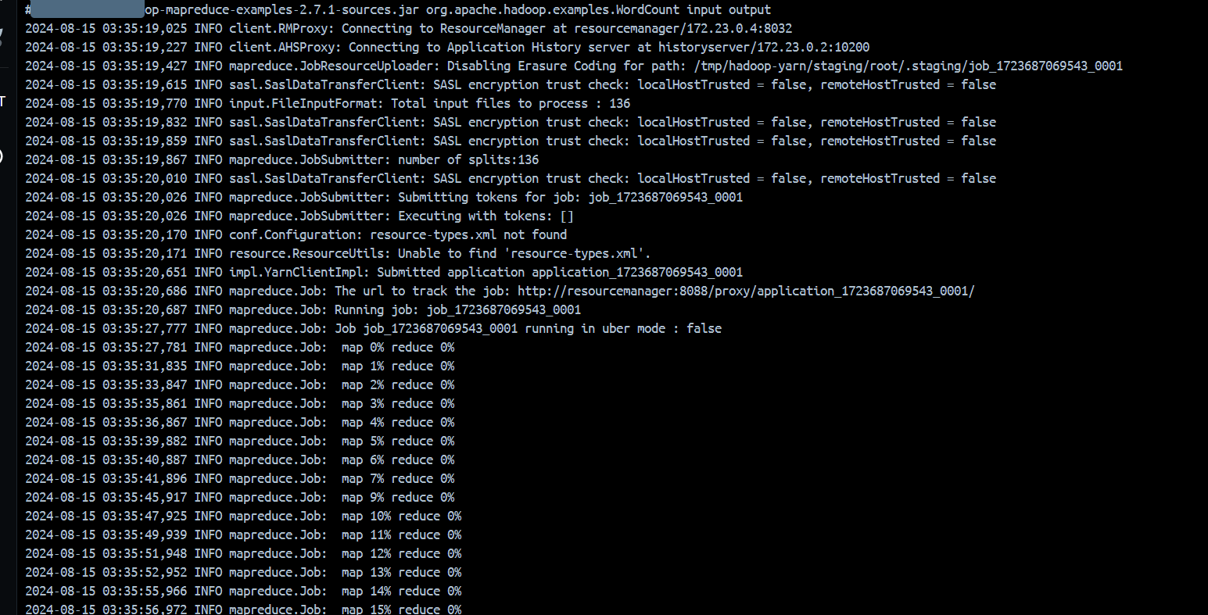

1. Provide a screenshot to show that you successfully executed the cat command to display the contents of the file.

